WEEK 5
TASK 5.1 : MAXIMUM SUBARRAY
PROGRAM:
class Solution {
public int maxSubArray(int[] nums) {
int currentSum = nums[0];
int maxSum = nums[0];
for (int i = 1; i < nums.length; i++) {
currentSum = Math.max(nums[i], currentSum + nums[i]);
maxSum = Math.max(maxSum, currentSum);
}
return maxSum;
}
}
OUTPUT:
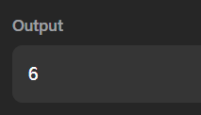

TASK 5.2: THE BIRTHDAY BAR
PROGRAM:
import java.util.*;
public class Solution {
public static int birthday(List<Integer> s, int d, int m) {
int count = 0;
for (int i = 0; i <= s.size() - m; i++) {
int sum = 0;
for (int j = i; j < i + m; j++) {
sum += s.get(j);
}
if (sum == d) {
count++;
}
}
return count;
}
public static void main(String[] args) {
Scanner sc = new Scanner(System.in);
int n = sc.nextInt();
List<Integer> s = new ArrayList<>();
for (int i = 0; i < n; i++) {
s.add(sc.nextInt());
}
int d = sc.nextInt();
int m = sc.nextInt();
System.out.println(birthday(s, d, m));
sc.close();
}
}
OUTPUT:

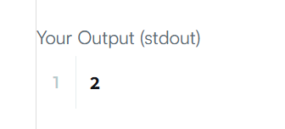

TASK 5.3: MAXSUBARRAY
PROGRAM:
import java.io.*;
import java.util.*;
class Result {
public static List<Integer> maxSubarray(List<Integer> arr) {
int current = arr.get(0);
int maxSubarray = arr.get(0);
int maxSubsequence = 0;
int largestNegative = arr.get(0);
for (int num : arr) {
if (num != arr.get(0)) {
current = Math.max(num, current + num);
maxSubarray = Math.max(maxSubarray, current);
}
if (num > 0) {
maxSubsequence += num;
}
if (num > largestNegative) {
largestNegative = num;
}
}
if (maxSubsequence == 0) {
maxSubsequence = largestNegative;
}
List<Integer> result = new ArrayList<>();
result.add(maxSubarray);
result.add(maxSubsequence);
return result;
}
}
public class Solution {
public static void main(String[] args) throws Exception {
BufferedReader br = new BufferedReader(new InputStreamReader(System.in));
int t = Integer.parseInt(br.readLine().trim());
while (t-- > 0) {
int n = Integer.parseInt(br.readLine().trim());
List<Integer> arr = new ArrayList<>();
while (arr.size() < n) {
String[] parts = br.readLine().trim().split("\\s+");
for (String s : parts) {
if (!s.isEmpty()) {
arr.add(Integer.parseInt(s));
}
}
}
List<Integer> result = Result.maxSubarray(arr);
System.out.println(result.get(0) + " " + result.get(1));
}
}
}
OUTPUT:
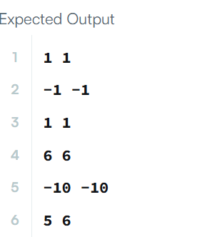

TASK 5.4:MAXIMUM SUB CIRCULAR SUBARRAY
PROBLEM:
class Solution {
public int maxSubarraySumCircular(int[] nums) {
int total = 0;
int currentMax = 0;
int maxSum = nums[0];
int currentMin = 0;
int minSum = nums[0];
for (int num : nums) {
currentMax = Math.max(num, currentMax + num);
maxSum = Math.max(maxSum, currentMax);
currentMin = Math.min(num, currentMin + num);
minSum = Math.min(minSum, currentMin);
total += num;
}
if (maxSum < 0) {
return maxSum;
}
return Math.max(maxSum, total - minSum);
}
}
OUTPUT:
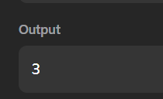

TASK 5.5:STRING TO INTEGER
PROGRAM:
class Solution {
public int myAtoi(String s) {
int i = 0;
int n = s.length();
while (i < n && s.charAt(i) == ' ') {
i++;
}
int sign = 1;
if (i < n && (s.charAt(i) == '+' || s.charAt(i) == '-')) {
if (s.charAt(i) == '-') {
sign = -1;
}
i++;
}
long num = 0;
while (i < n && Character.isDigit(s.charAt(i))) {
num = num * 10 + (s.charAt(i) - '0');
if (sign == 1 && num > Integer.MAX_VALUE) {
return Integer.MAX_VALUE;
}
if (sign == -1 && -num < Integer.MIN_VALUE) {
return Integer.MIN_VALUE;
}
i++;
}
return (int)(sign * num);
}
}
OUTPUT:
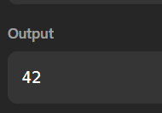

TASK 5.6 : ALTERNATING CHARACTERS
PROGRAM:
import java.io.*;
import java.util.*;
public class Solution {
public static int alternatingCharacters(String s) {
int deletions = 0;
for (int i = 1; i < s.length(); i++) {
if (s.charAt(i) == s.charAt(i - 1)) {
deletions++;
}
}
return deletions;
}
public static void main(String[] args) throws IOException {
BufferedReader br = new BufferedReader(
new InputStreamReader(System.in)
);
int q = Integer.parseInt(br.readLine().trim());
for (int i = 0; i < q; i++) {
String s = br.readLine().trim();
int result = alternatingCharacters(s);
System.out.println(result);
}
br.close();
}
}

OUTPUT:
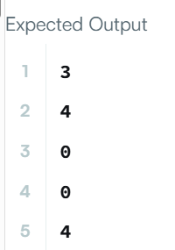

TASK 5.7 :LONGEST SUBSTRING
PROGRAM:
class Solution {
public int lengthOfLongestSubstring(String s) {
int left = 0;
int maxLength = 0;
HashSet<Character> set = new HashSet<>();
for (int right = 0; right < s.length(); right++) {
while (set.contains(s.charAt(right))) {
set.remove(s.charAt(left));
left++;
}
set.add(s.charAt(right));
maxLength = Math.max(maxLength, right - left + 1);
}
return maxLength;
}
}
OUTPUT:
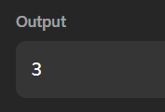

TASK 5.8:FIND AND REPLACE PATTERN
PROGRAM:
import java.util.*;
class Solution {
public List<String> findAndReplacePattern(String[] words, String pattern) {
List<String> result = new ArrayList<>();
for (String word : words) {
if (matches(word, pattern)) {
result.add(word);
}
}
return result;
}
private boolean matches(String word, String pattern) {
Map<Character, Character> map = new HashMap<>();
Map<Character, Character> reverseMap = new HashMap<>();
for (int i = 0; i < word.length(); i++) {
char w = word.charAt(i);
char p = pattern.charAt(i);
if (map.containsKey(p) && map.get(p) != w) {
return false;
}
if (reverseMap.containsKey(w) && reverseMap.get(w) != p) {
return false;
}
map.put(p, w);
reverseMap.put(w, p);
}
return true;
}
}
OUTPUT:
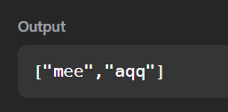

TASK 5.9: STRING MATCHING IN AN ARRAY
PROGRAM:
import java.util.*;
class Solution {
public List<String> stringMatching(String[] words) {
List<String> result = new ArrayList<>();
for (int i = 0; i < words.length; i++) {
for (int j = 0; j < words.length; j++) {
if (i != j && words[j].contains(words[i])) {
result.add(words[i]);
break;
}
}
}
return result;
}
}
OUTPUT:
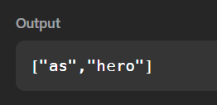

TASK 5.10 :NAÏVE ALGORITHM
PROGRAM:
import java.util.ArrayList;
public class GFG {
static ArrayList<Integer> search (String pat, String txt) {
int m = pat.length();
int n = txt.length();
ArrayList<Integer> ans = new ArrayList<Integer>();
for (int i = 0; i <= n - m; i++) {
int j;
for (j = 0; j < m; j++) {
if (txt.charAt(i + j) != pat.charAt(j)) {
break;
}
}
if (j == m) {
ans.add(i);
}
}
return ans;
}
public static void main(String[] args) {
String txt = "aabaacaadaabaaba";
String pat = "aaba";
ArrayList<Integer> res = search(pat, txt);
for (int i = 0; i < res.size(); i++) {
System.out.print(res.get(i));
if (i < res.size() - 1) {
System.out.print(" ");
}
}
}
}
OUTPUT:
